LAB ASSIGNMENT-8



NAME: M Gyanada Chowdary

REG.NO: 21bce7727

COURSE: Computer Networks

SLOT: L21+22

TASK:

create and configure a network and implement FTP & HTTP protocols in that network.

**FTP(File Transfer Protocol)**

STEP 1:

Create a Network With one server, switch and Two PC’s

And give IP configurations and default gateway

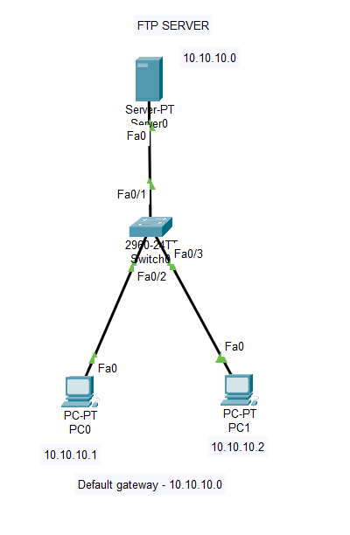

Step 2:

Go to Server🡪 Services and switch off all the services except FTP.

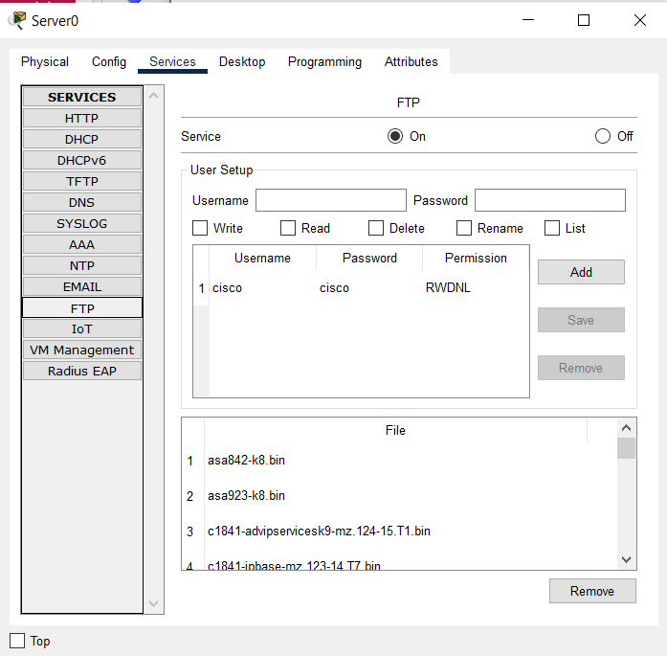

Step 3:

Now

Create a user with

Username: abc

Password:123

Give all WRDRL permissions and click ‘Add’

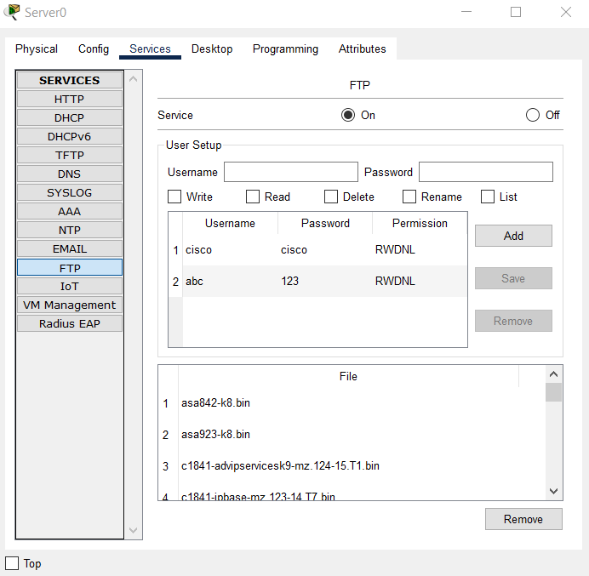

Step 4:

Go to PC2 🡪 Command prompt

Check FTP

Ipconfig

ftp 10.10.10.0

* Give Username and Password

dir

help

delete (Any File)

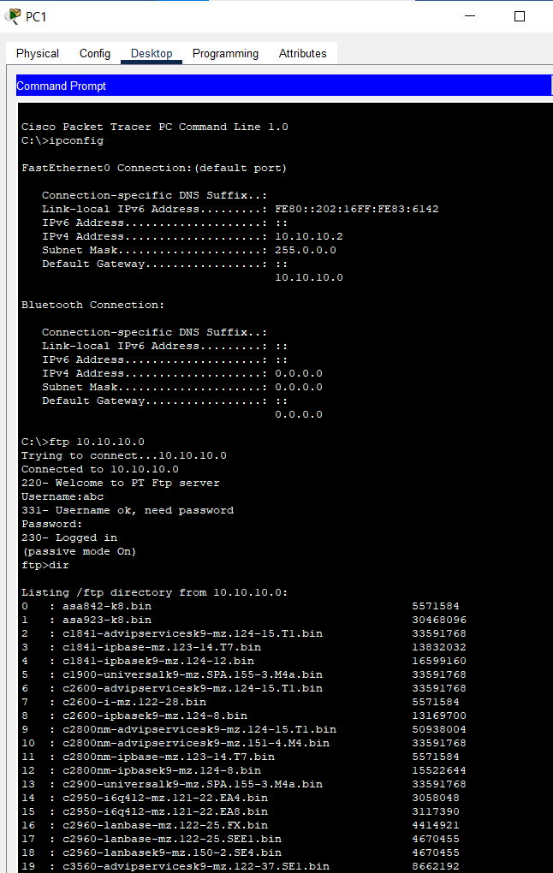

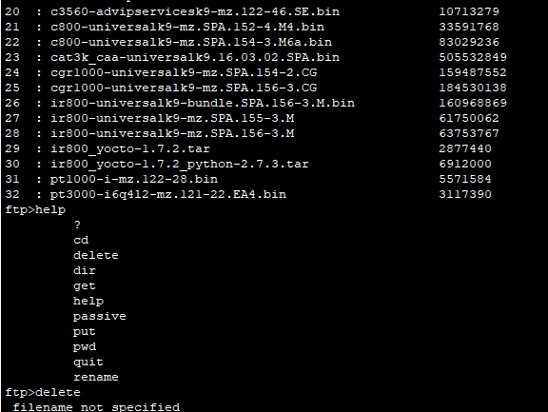

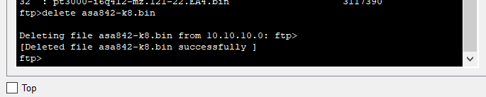

**HTTP**

Step 1:

Create a network with one Switch, Server and 3 PC’s

And give IP configurations and Default Gateways.

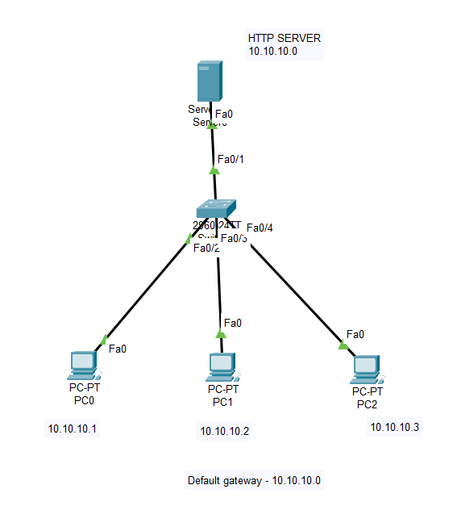

Step 2:

Go to Server🡪 Services and switch off first 3 services after HTTP.

Now go to HTTP Service🡪 index.html file 🡪 Edit

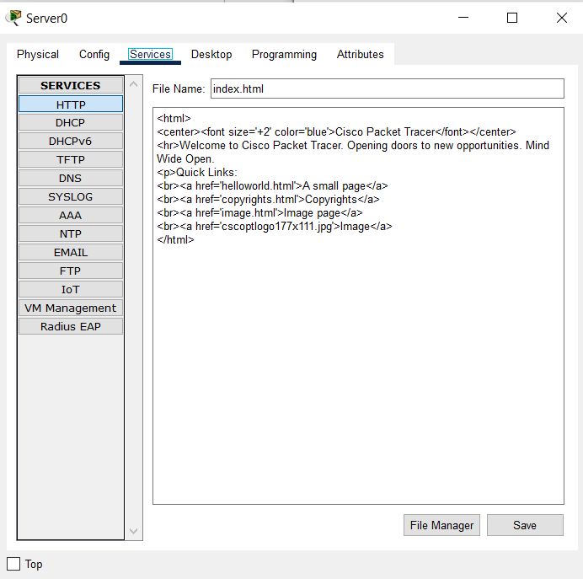

Change the above to following:

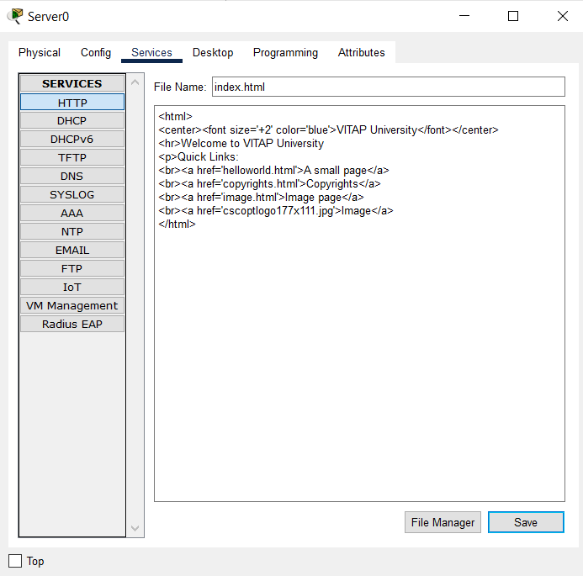

Step 3:

Go to PC2🡪desktop🡪Web browser 🡪 type URL = 10.10.10.0

Check HTTP

